SPARKSQL STEPS
1.Sign up to databricks community free edition - personal mail id
2. go to databricks community free edition
3. use default cluster (serverless)
Now for uploading your file in data bricks
- Catalog 1. Create catalog - capstone project
2. create schema inside catalog – ecommerce or u can use default
3.create volume – filestore(where you need to store ur files)
Now click add data , and browse your file and select the catalog in which you want to store.
This create a path for your file - /Volumes/capstone_project/ecommerce/filestore/data.csv
Now the steps follows :

2.Create a data frame using your data set
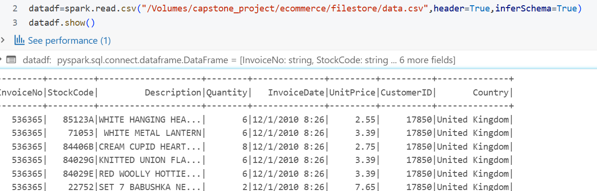

3.Create a Temp view for querying on data

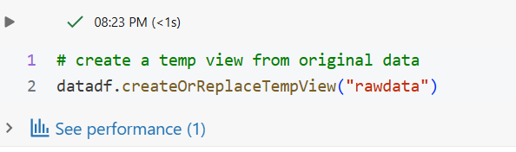

4. Count no.of records before cleaning the data
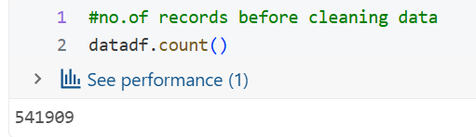

5.Create a Dataframe for cleaned data
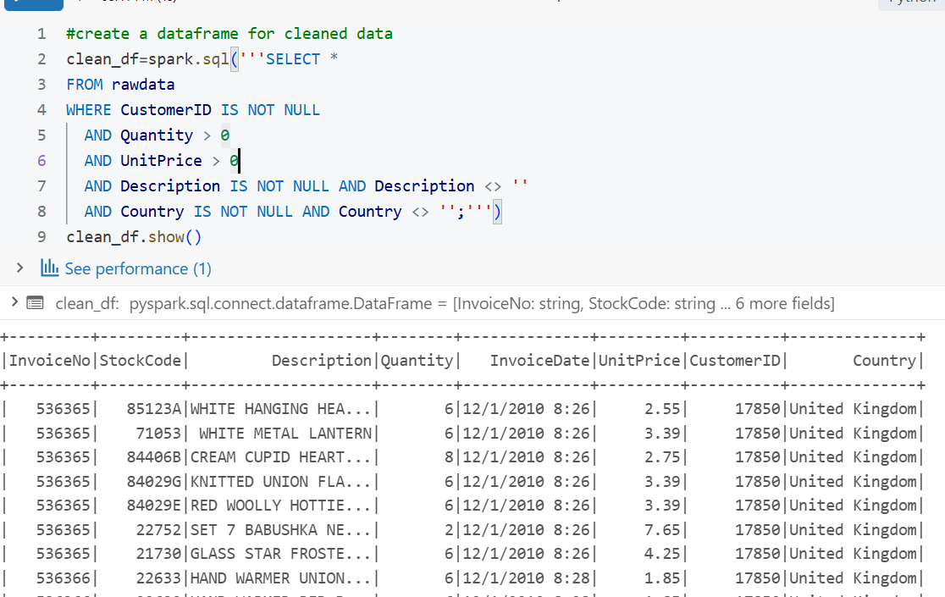

6.Count records after cleaning data
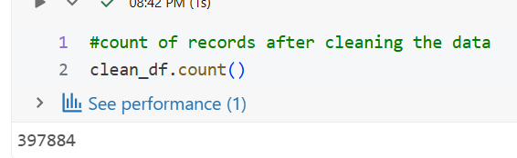

7.write dataframe into parquet file and reading parqet file because parquet file is more compressed format and fetching results is too easy . best optimized queries can be written
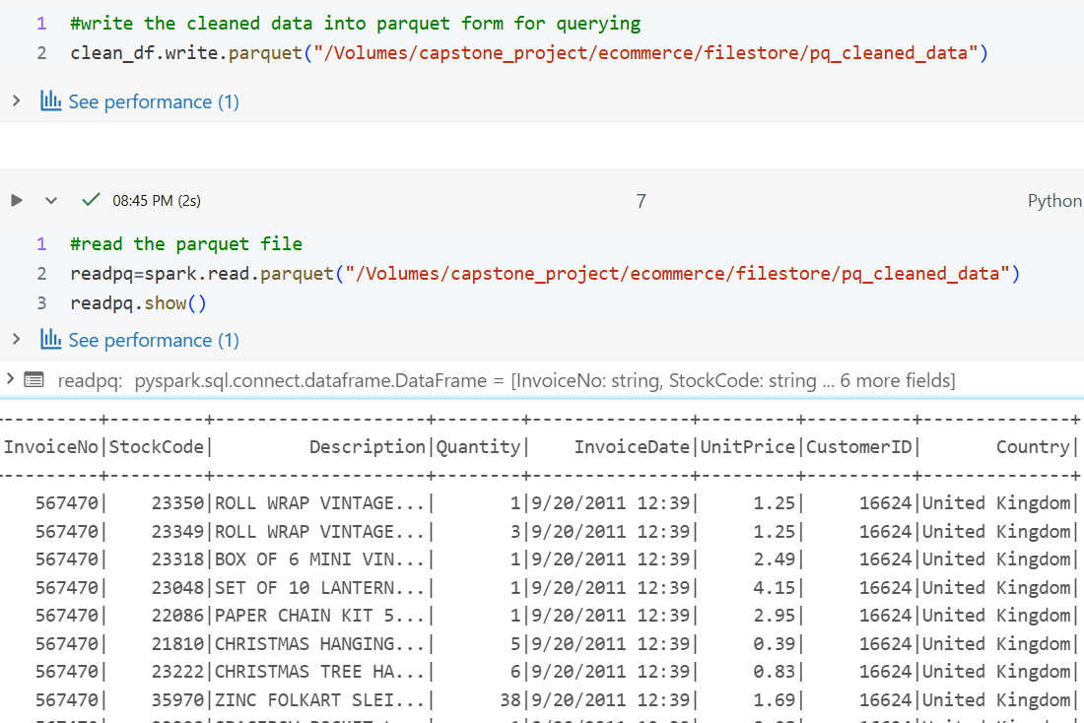
8.Create tempview for this parquet file
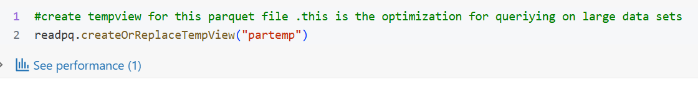
Now we will query on this temp view .
3steps : write query for problem and store in data frame ,
next reduce partitions and convert to csv format ,
write display function to download

QUERY 7: To find count of customer ids having same invoice number
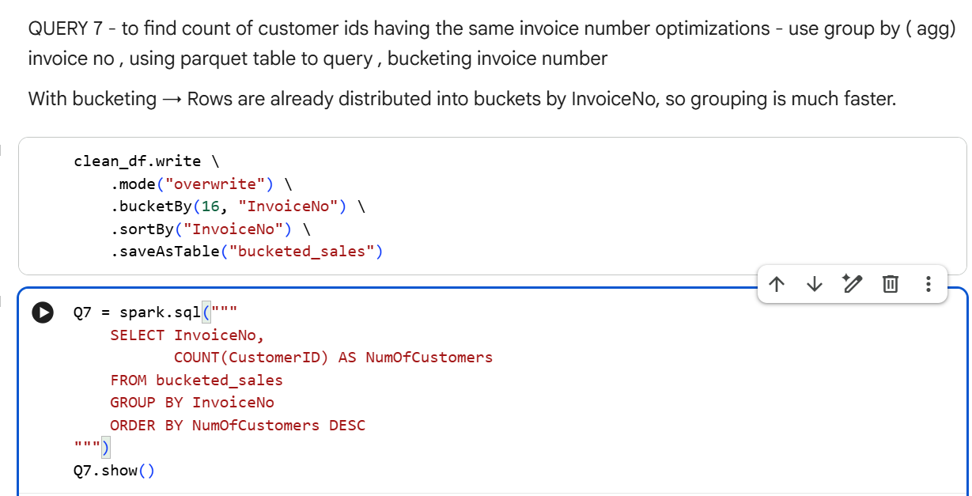

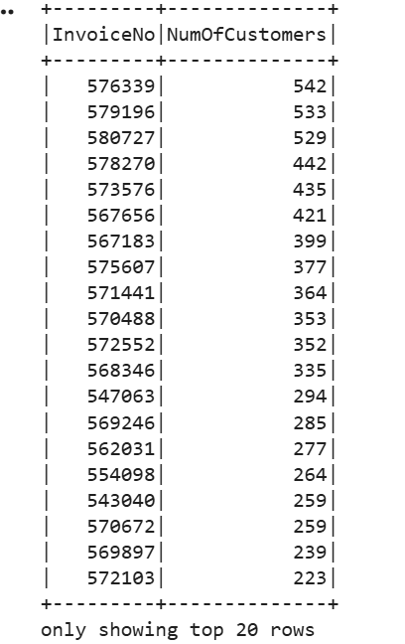

QUERY 16 - TO FIND DATA WHERE UNIT PRICE > 5 we can use cache to store our data in memory to execute queries and for using that the data set should be small it should not be large
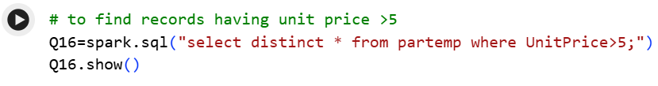

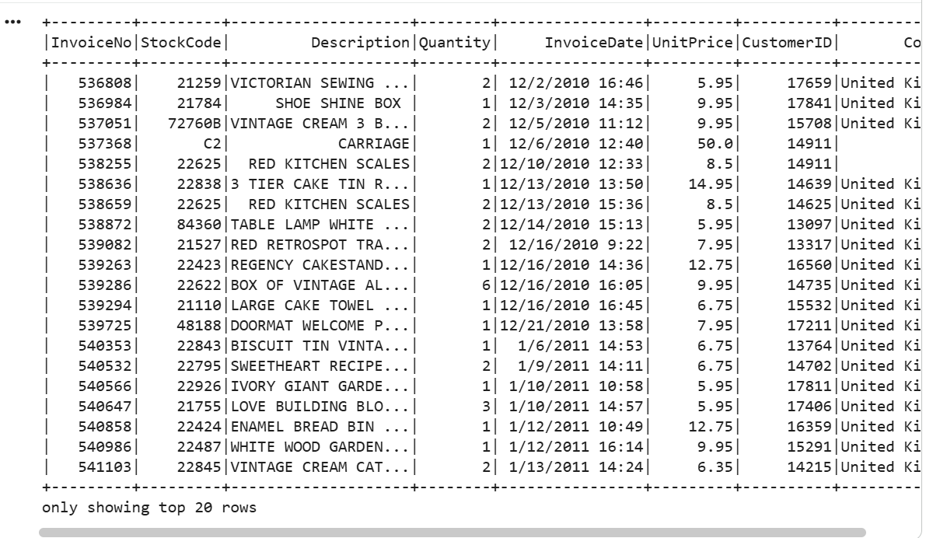

Query - 18 , customer ids containing more than 500 invoices

Used bucketing on customer id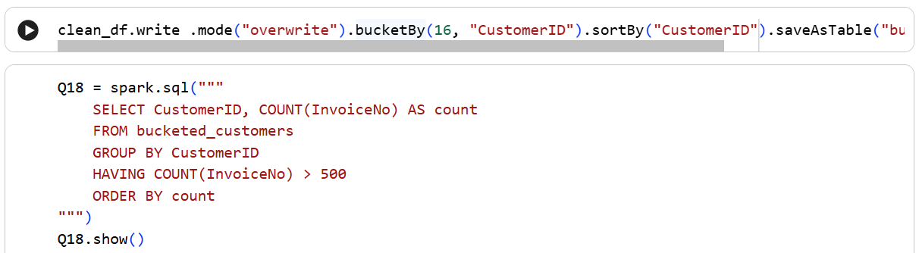

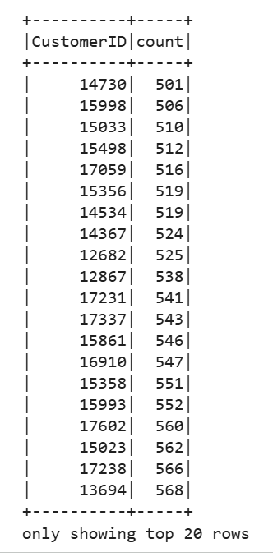

Q-19 To find customer ids with stock code 22752 Bucketing on stock code
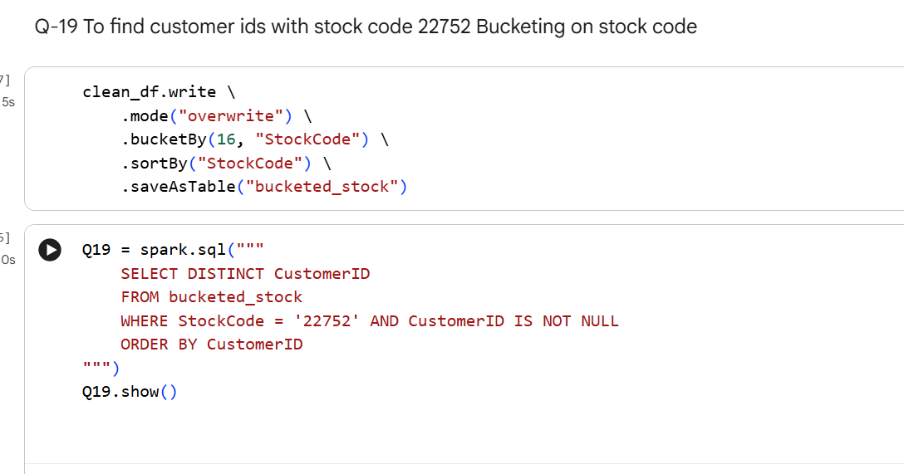

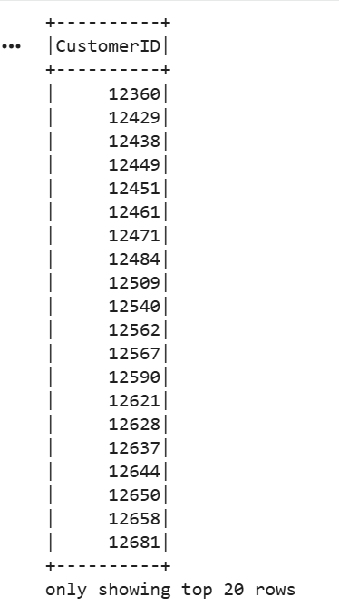

QUERY - 20 #stock codes having unit price >10 and count of stock codes
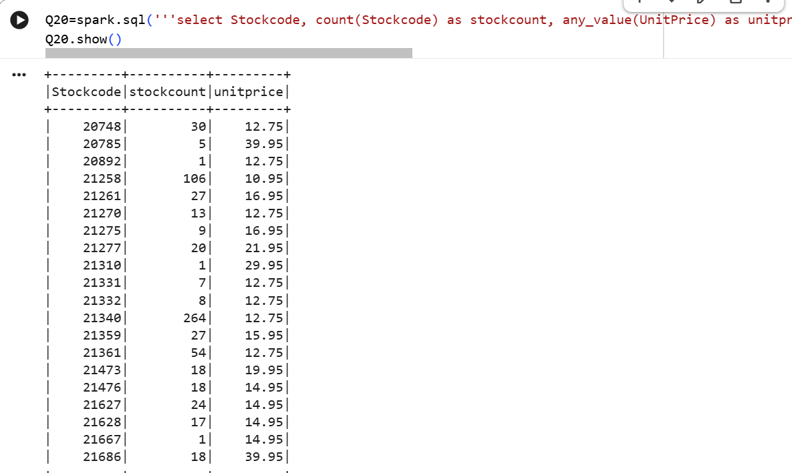
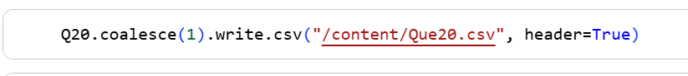

GENERATING REPORTS IN POWERBI

REPORT 1: To check the count of customers for each invoice in descending order
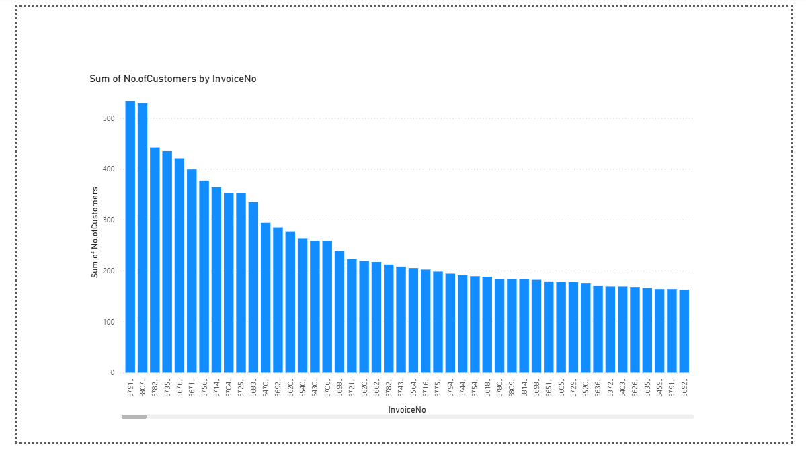
GO to power Bi Get data csv /text select file Transform
In transforming make sure u have proper data type for your columns
No null values in columns , Rename columns if needed
IN file select close and apply
Now u have a web ui in right you can view your Table Q7 and right you can have models in which you want to visualize .
Here we visualized the count of customers for each invoice . I have sorted in transformations so I got in a pattern.

REPORT 2 : TOP 10 highest revenue generated stockcodes?

Revenue generated by each stock
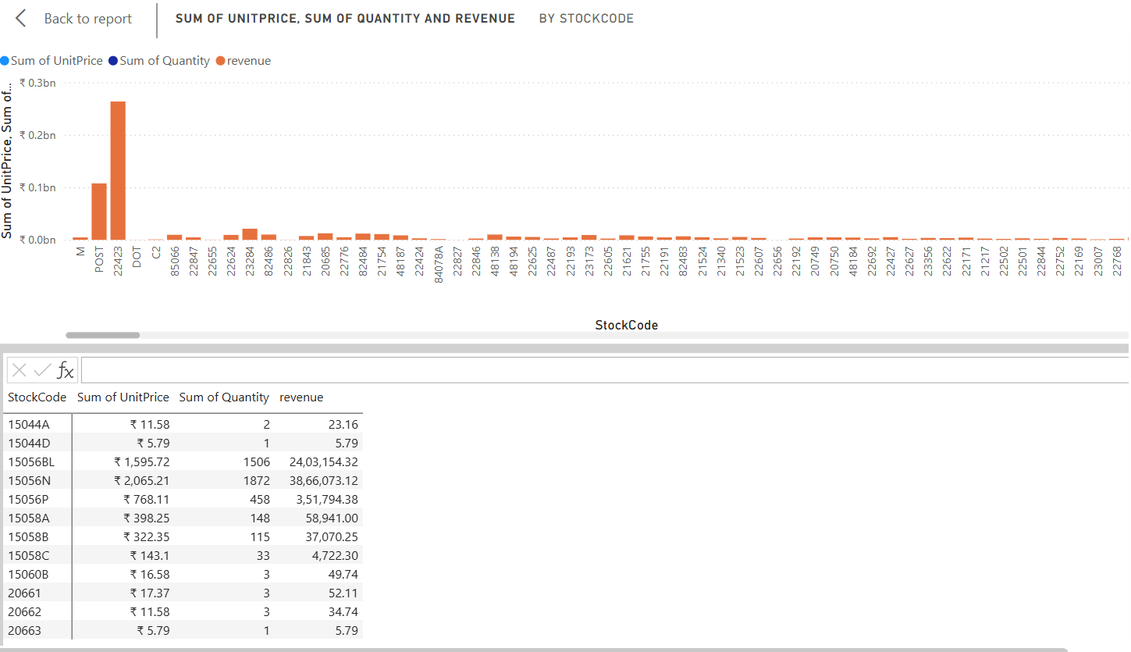

Top 10 revenue generated stocks
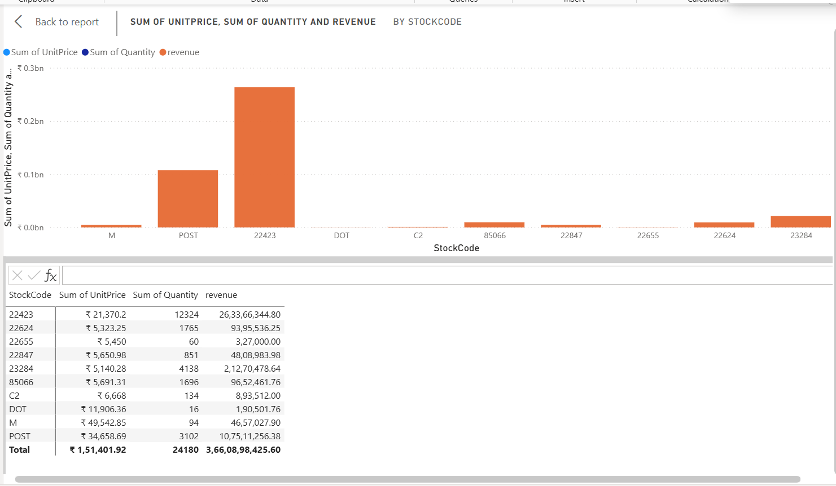
We used calculated measure to find out the revenue
Revenue = unit price * quantity
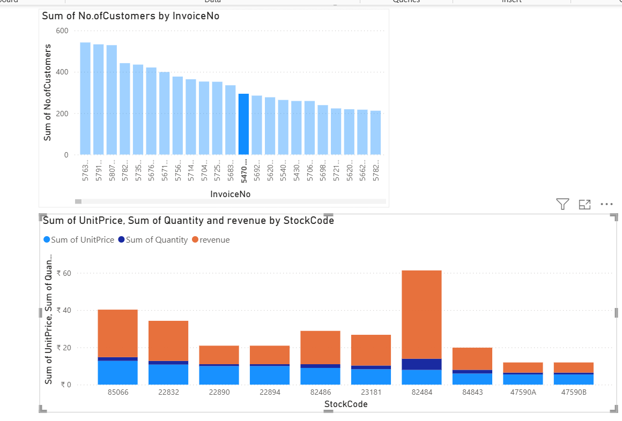
Here we can observe how many stock codes are having 54702 invoice no and revenues of each .
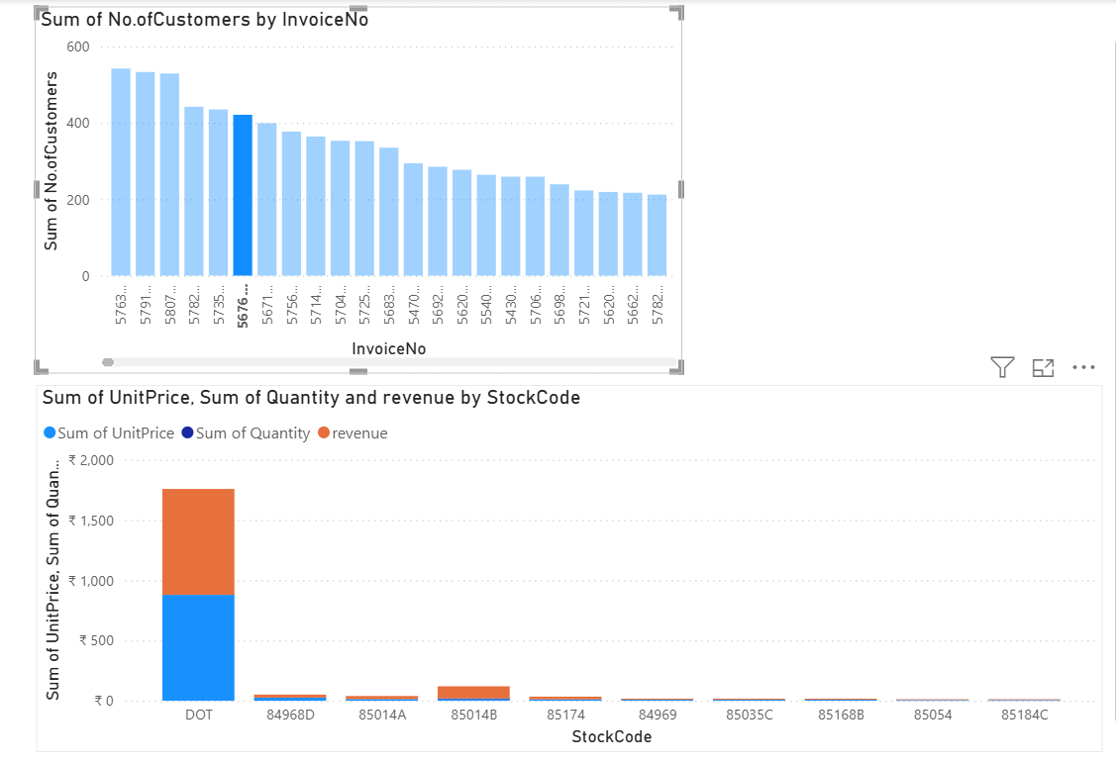

CHALLENGES FACED:
Bucketing and partitioning is not supported in data bricks because of serverless cluster
